Quick Reference Guide – Naznet Self-Service
Finance Query: The New Naznet Budget Summary
IMPORTANT CONSIDERATIONS
- The old Naznet Budget Summary will be going away in June 2021
- The new Naznet Self-Service Finance Query allows you to:
  - View multiple fiscal years
  - Export to a csv file and open the file in Excel
  - Save and name multiple selection criteria so you can go view the results for the same accounts without having to enter account numbers each time

General Login
- Go to the site https:mynaznetss.naz.edu
- Login with your MyNaz username and password
- Click the “Sign In” button

View Your Budget or Restricted Account
- Select “Financial Management”
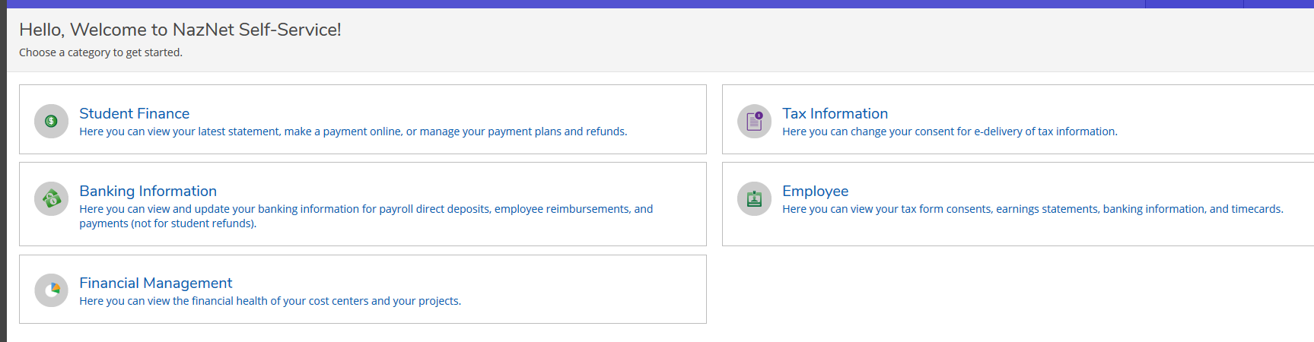
- Select “Finance Query”
NOTE: Once you set a default criteria it will be executed automatically when you come to this screen.
- Click “Got it”

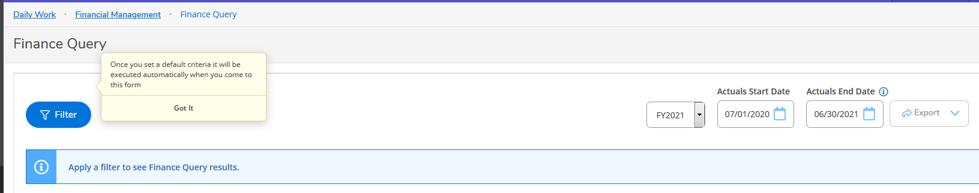

- Select the FY (Fiscal Year Ending), Actuals Start Date, and Actuals End Date that you want included in your report

- Click “Filter” to select the Fund(s), Unit(s), Object(s) that you want to include
- To view all the accounts you have access to (similar to “My Budget” in Naznet)
  - Skip to Step 8 and click “Apply Filter”

- To select specific accounts to view you can:
  - Enter one fund (ie: 11) or multiple funds (ie: 11-17 or 11,12)
  - Include ranges separated by “-“ or “,”
  - Leave a component field blank (ie: object) if you want all objects from a certain unit to be included

- Answer whether you want to include active accounts with no activity (meaning the account has a $0 balance)

- Select Sort Options
- Recommend Sort by Fund and Unit
- Check the box for Subtotal
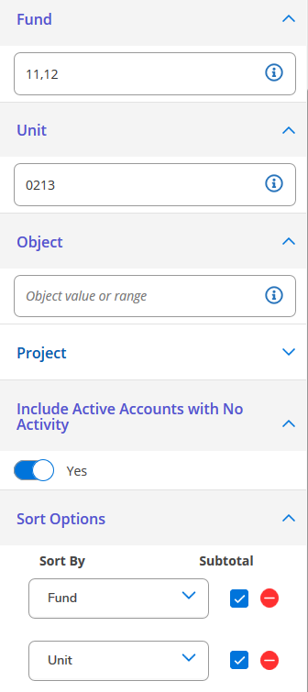
(You can ignore the “Project” field – we don’t use that functionality)

- If you will need to pull up this same group of account numbers again click “Save Criteria” if not skip to Step 8.
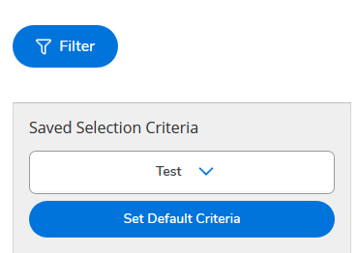
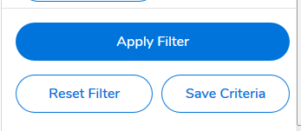

- Things to note when you “Save Criteria”
  - You can name the selection criteria when you save it
  - You can either override a previous criteria saved or save multiple criteria under different names
  - Your Saved Selection Criteria will appear just under the Filter button; click on the dropdown arrow to select a saved selection criteria. See the example above for the saved criteria “Test”

- Click “Apply Filter”
- Your results will appear
- You can select how many rows you want to appear on a page (25, 50 or 100)
- Scroll to the bottom of the page and you can see whether there are multiple pages
  - Click arrows to other pages as needed
Export Results
- Select the Export drop down arrow
- Click on Download CSV
- Open with Microsoft Excel (default) – Click OK
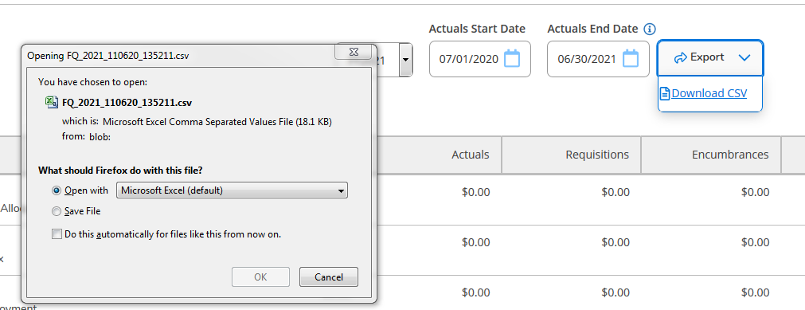

Account details (Drill Down)
- To view the account details click on the G/L account (ex. 11-1203002-53020)
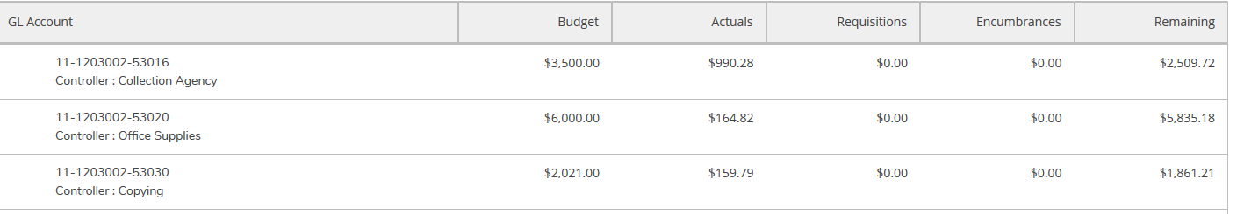

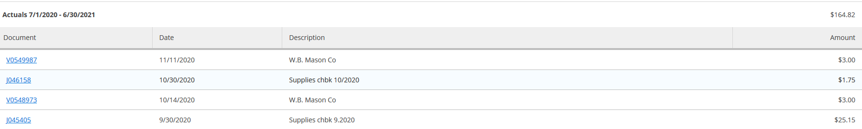

View a Different Fiscal Year for the Same Accounts
After you have “Applied Filter” and viewed your selected accounts, you can select a different fiscal year to view for the same set of accounts
- Click on the dropdown menu next to FY2021
- Select the fiscal year that you want to view (ie: FY2020)
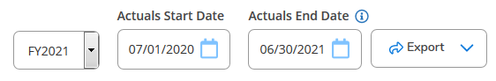
  - Note the start and end dates for the fiscal year will update automatically

- The filters will update and the next fiscal year results will be displayed

