Accommodate
Faculty Guide: How to Upload Exams
Uploading an exam to Accommodate will only allow access for SAS to administer your exam at the date and time designated on an exam request. This will not allow students direct access to an exam.
- Log into Accommodate.
- Select "Courses" on the left-hand sidebar.
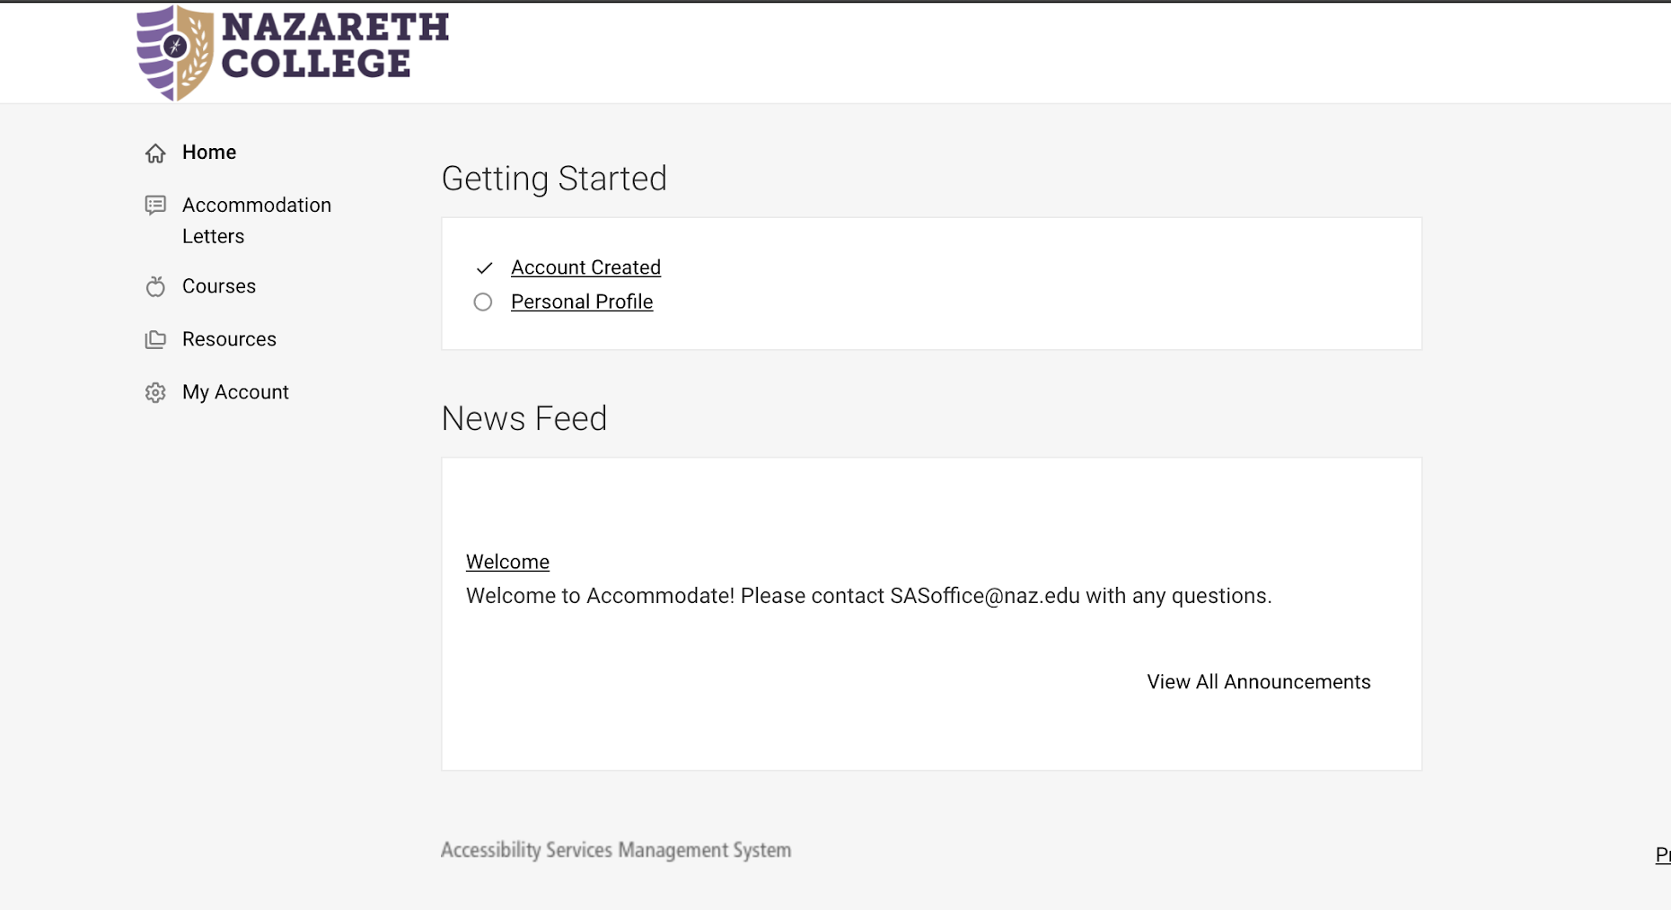

- Click on the course you’d like to upload the exam for.
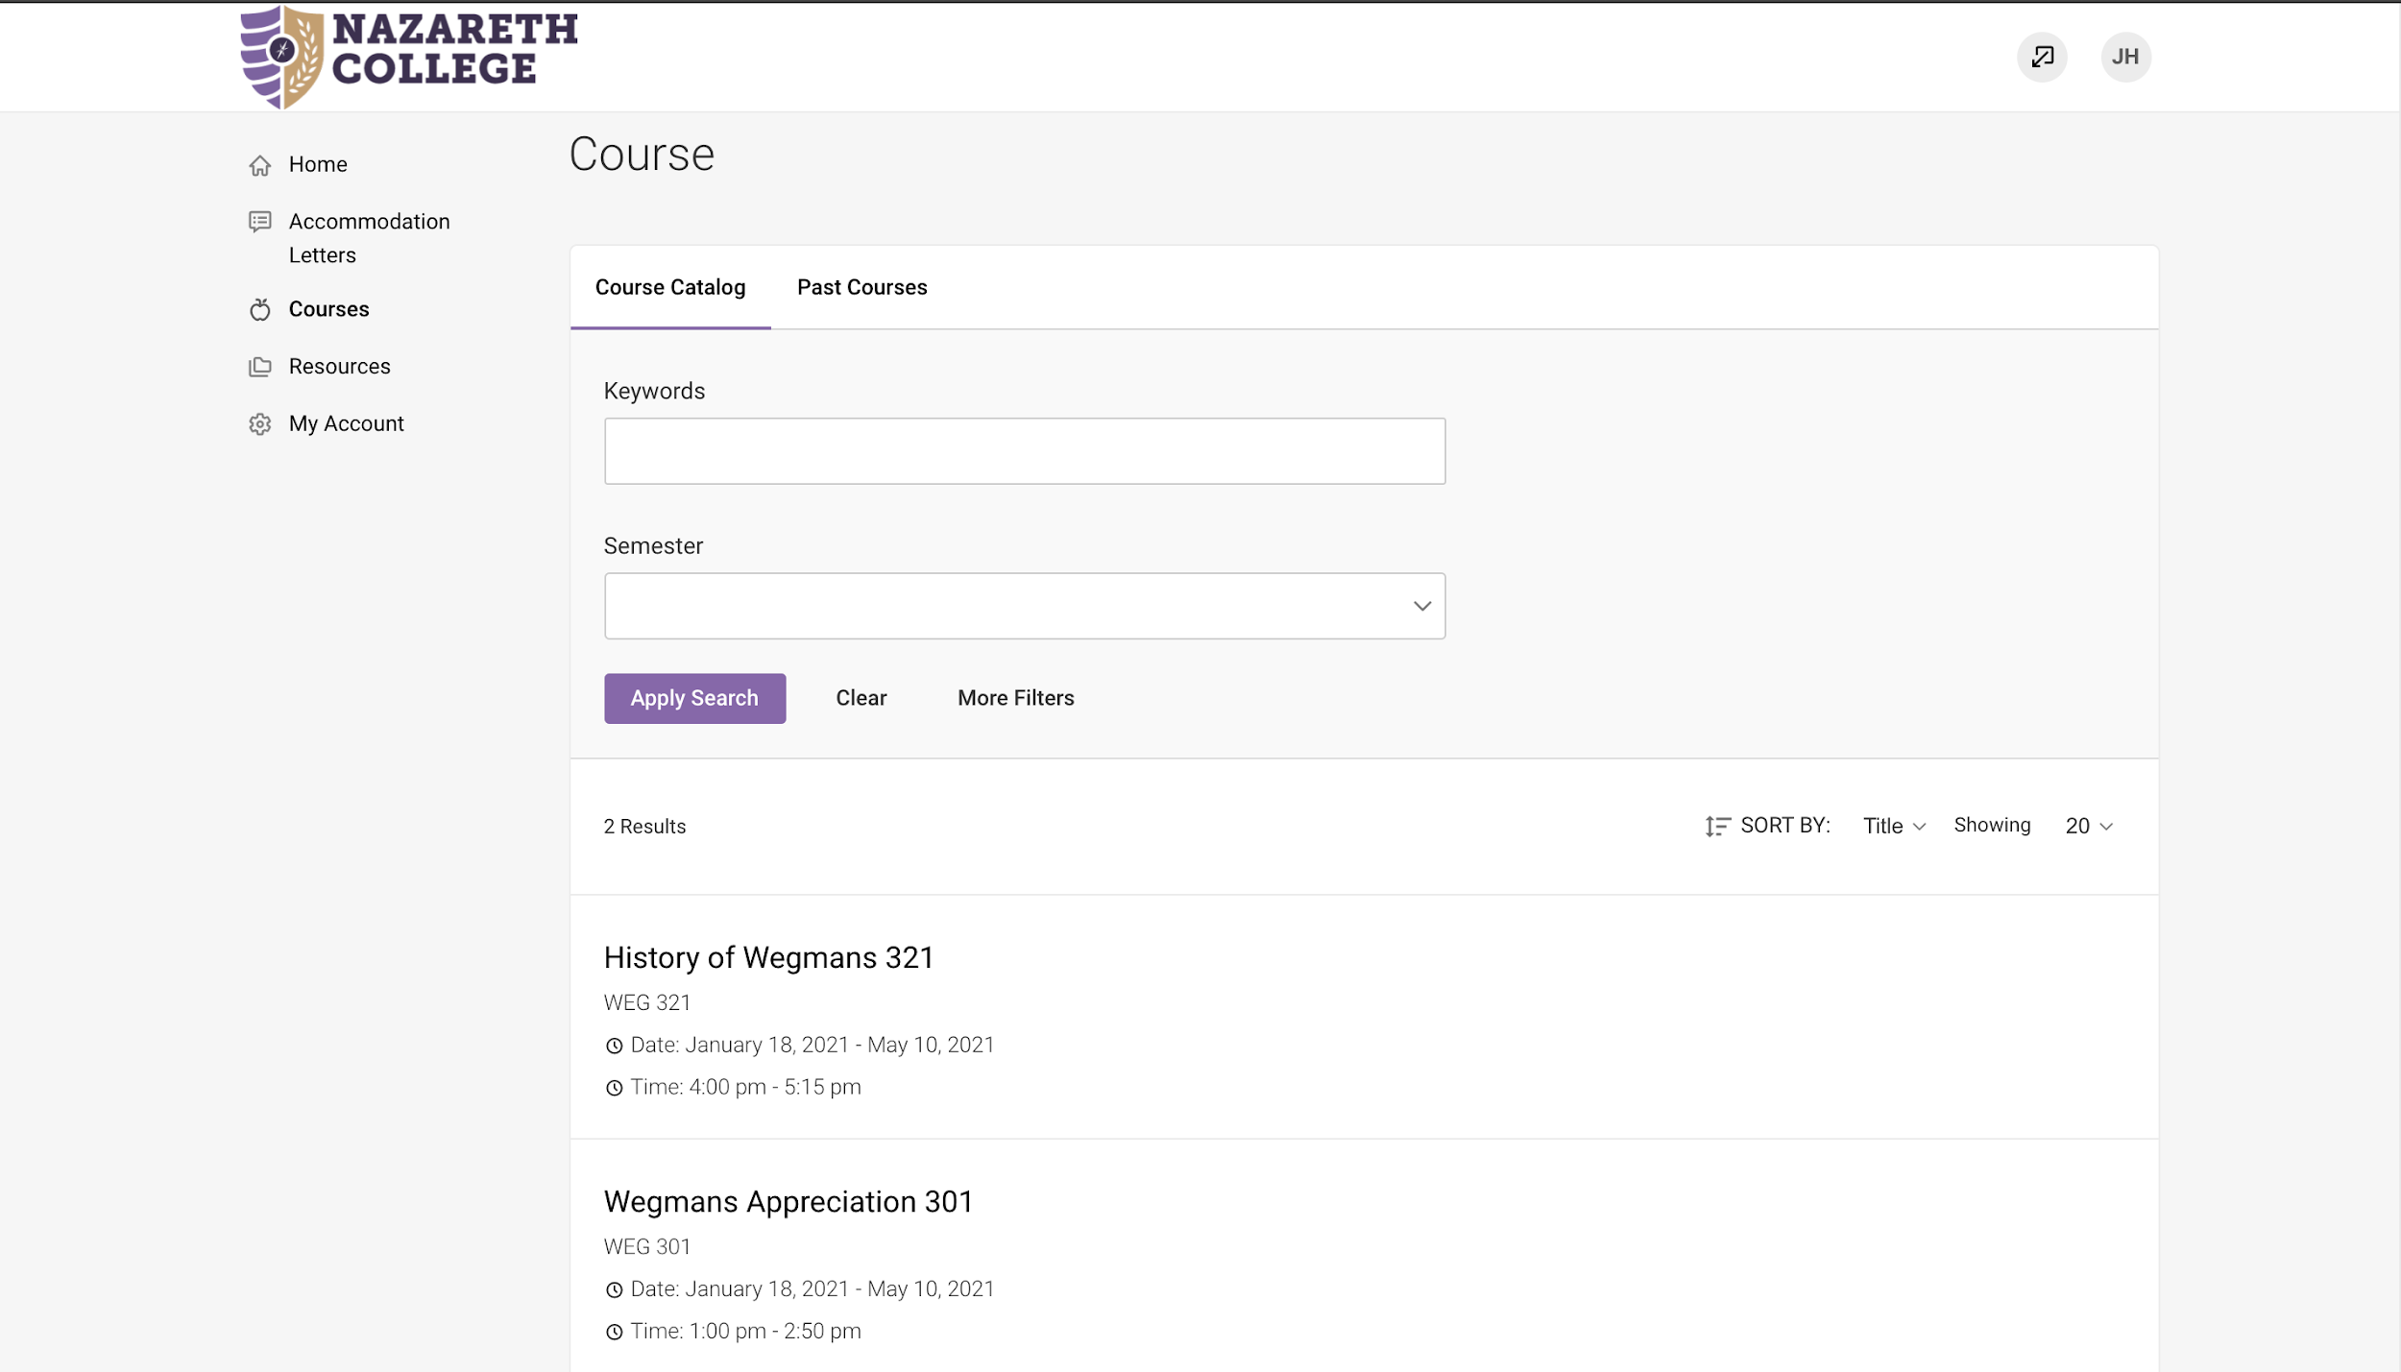

- Select "Upload Exam."
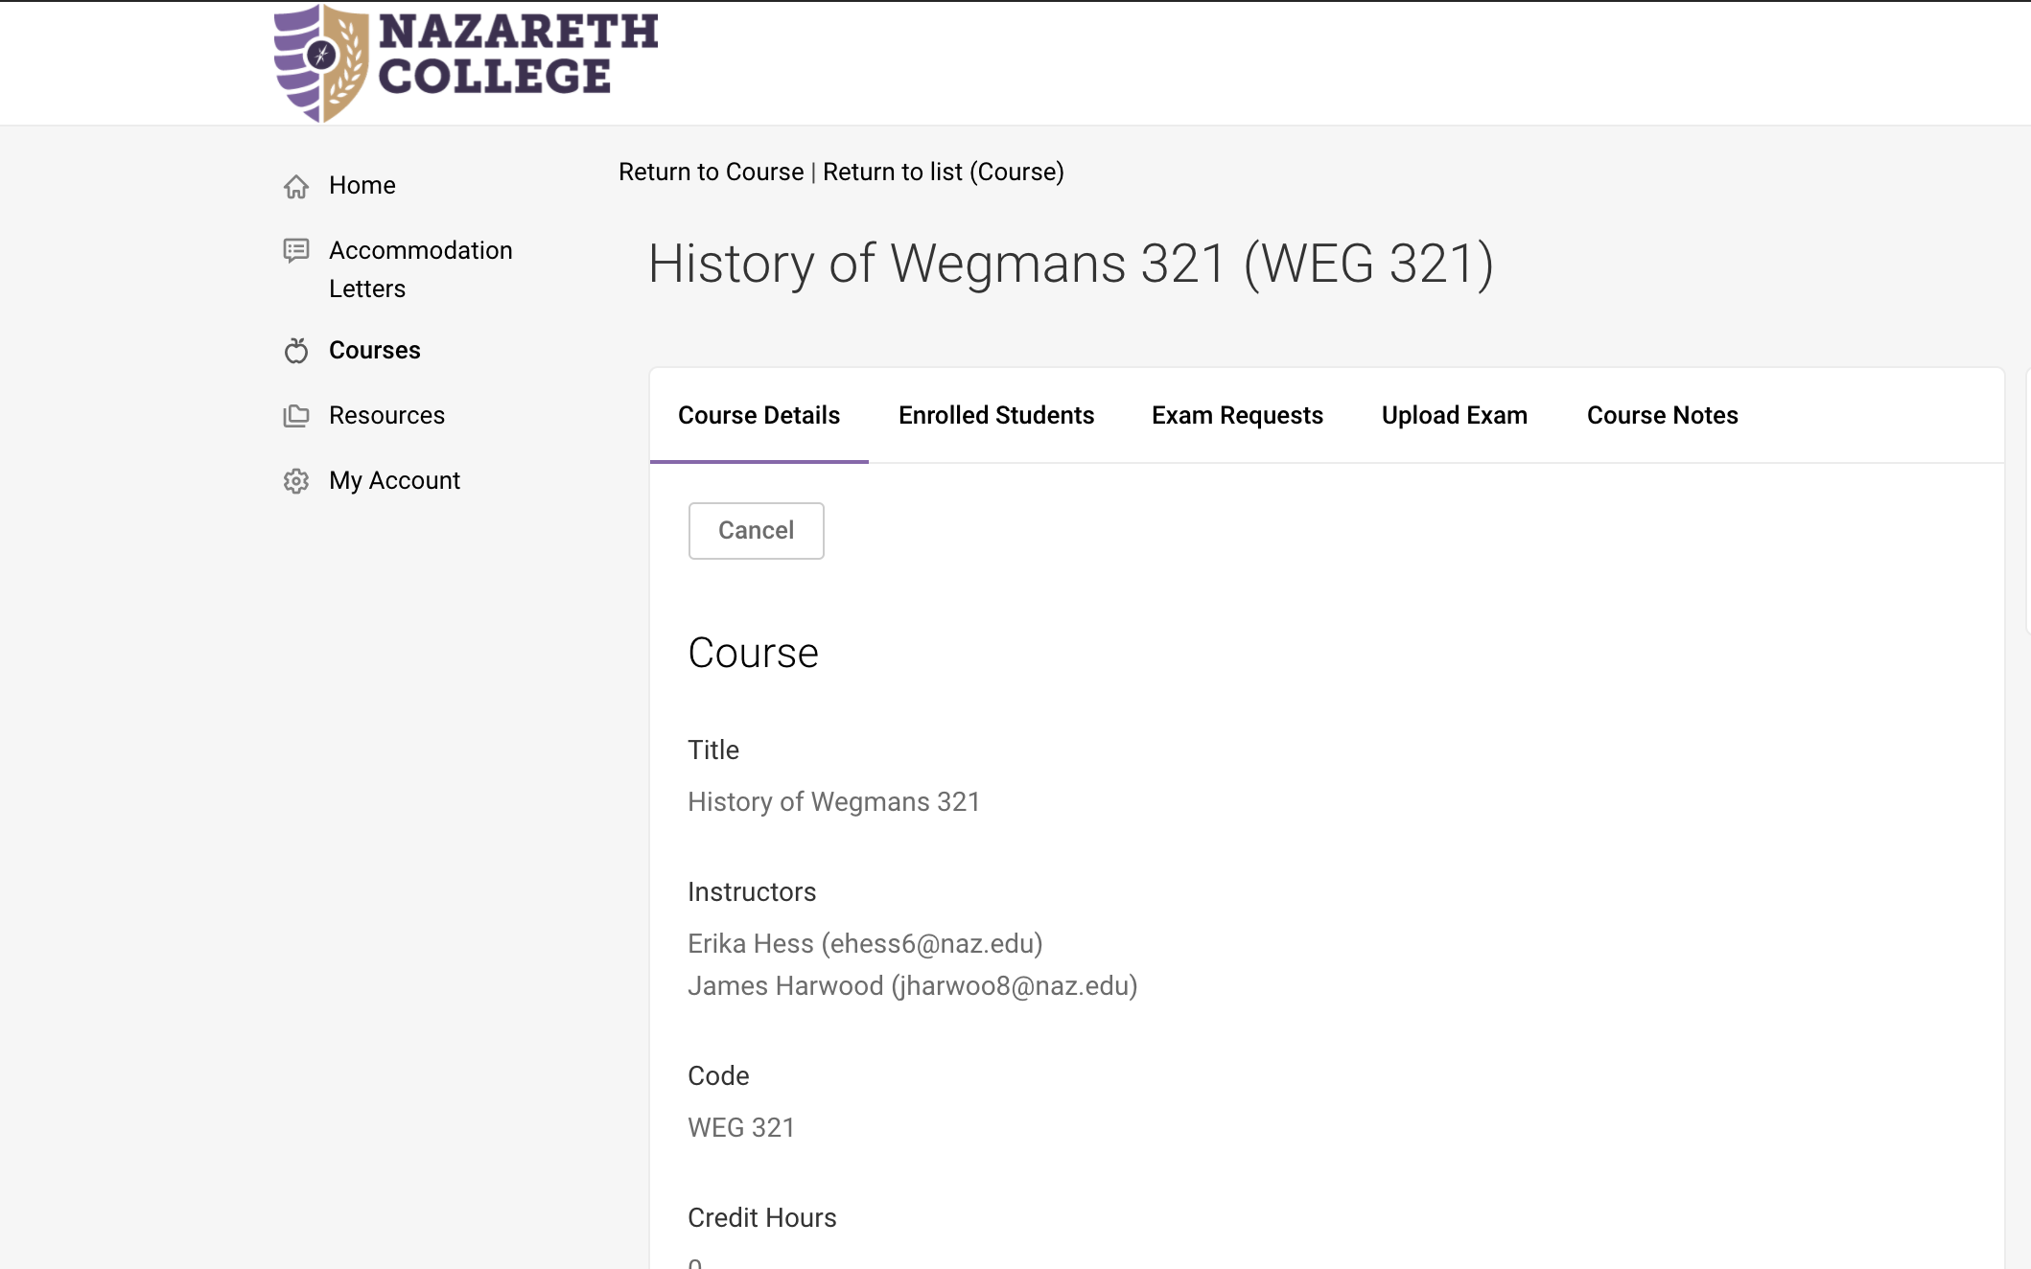

- Select “Add New Exam.”
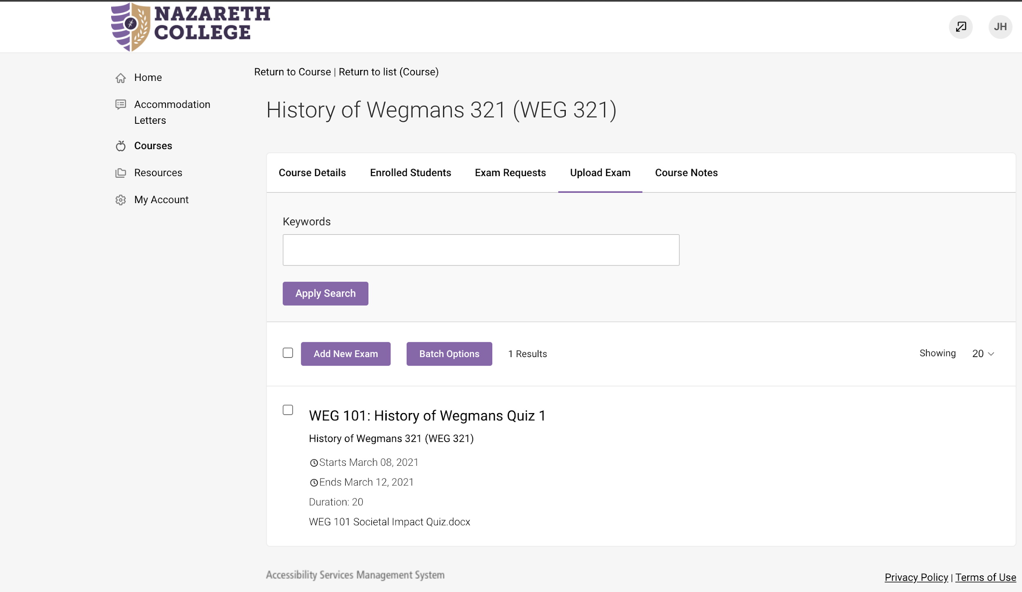

- Enter a title and if needed, a description.
- Upload your file. If you would like to attach multiple files, please condense them into a .zip file or submit additional files when approving a student’s exam request.
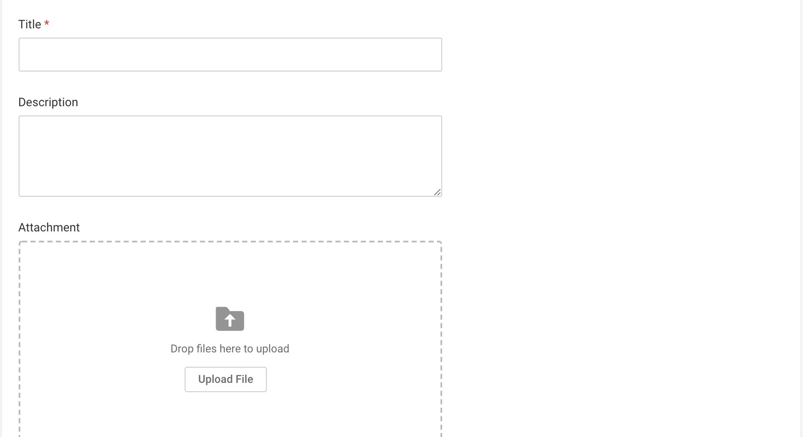

- Designate if this is a final exam. If yes, length will be assumed to be 2.5 hours unless otherwise stated. If no, please designate the length of time you will be allowing in class. The length specified will be used to calculate extended timing accommodations.
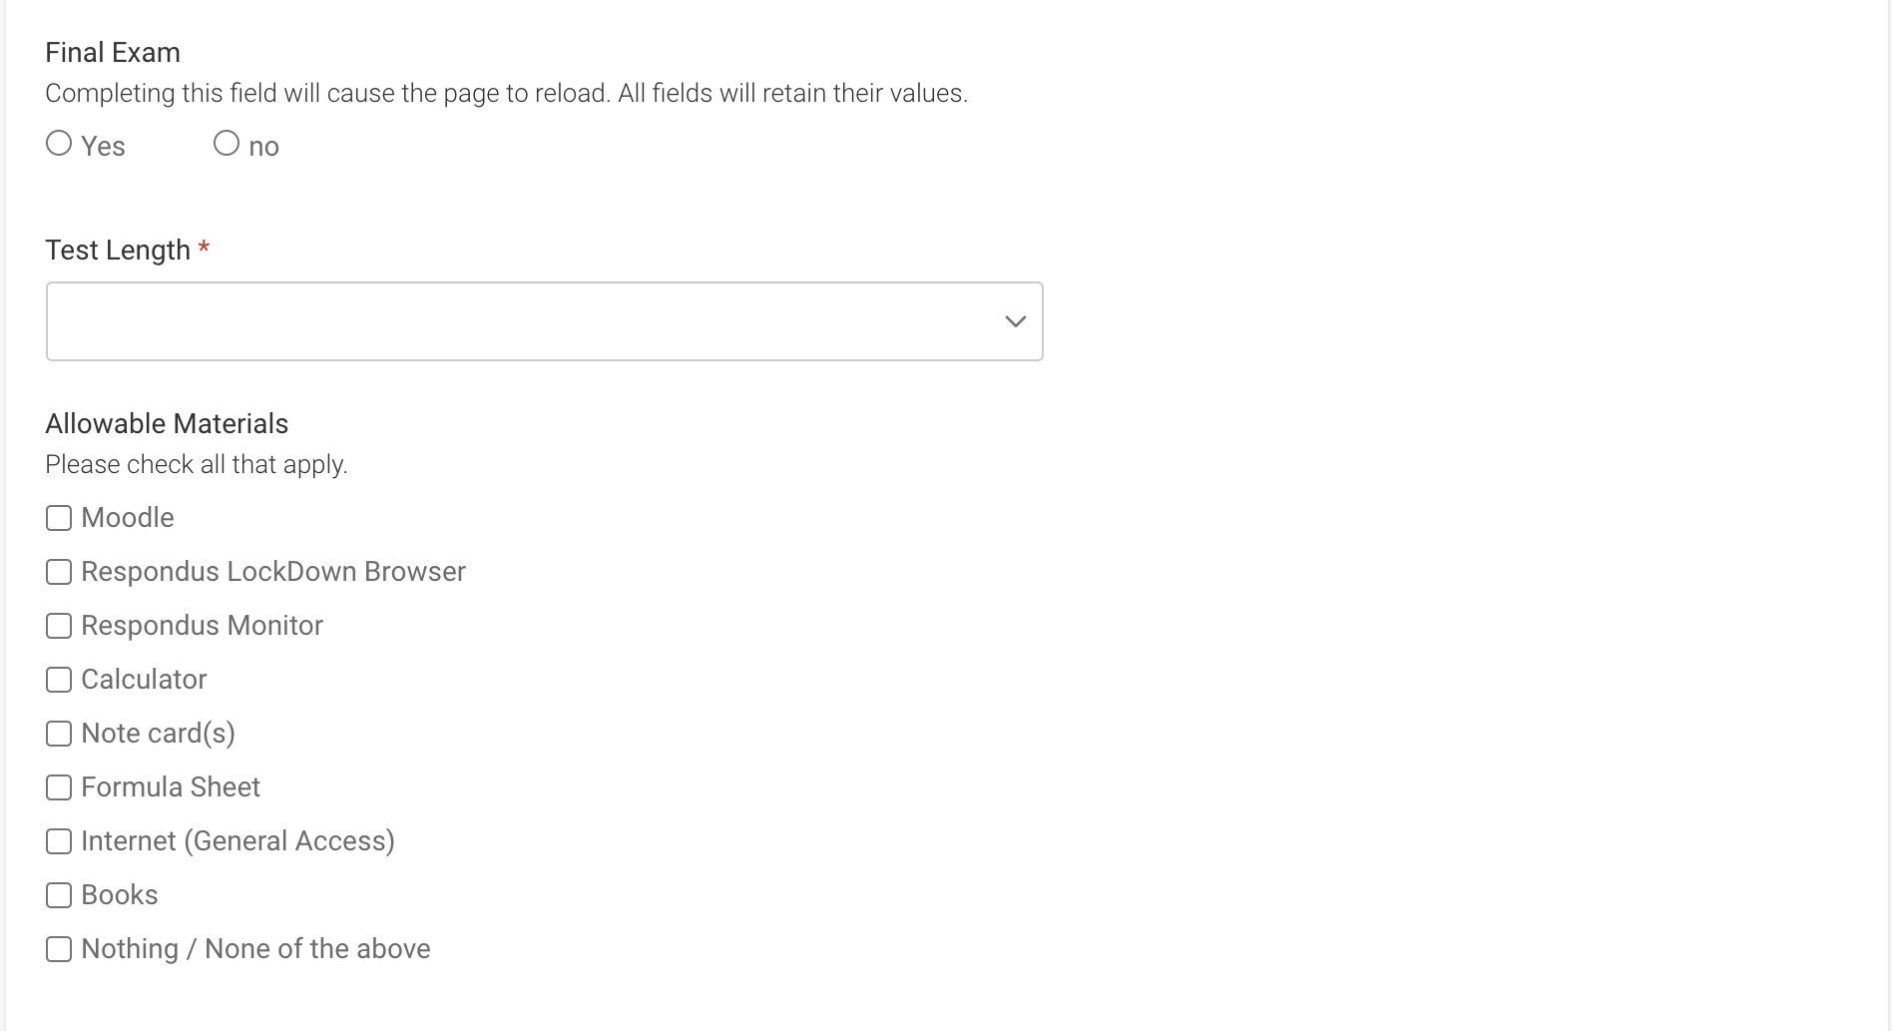

- Enter any relevant exam information such as allowable materials and contact information.
- Indicate how you’d like the exam to be returned to you, such as intercampus mail or scanned and emailed.
- Designate the date range and time when the exam is allowed to be given. This should include times you are available to address student questions.
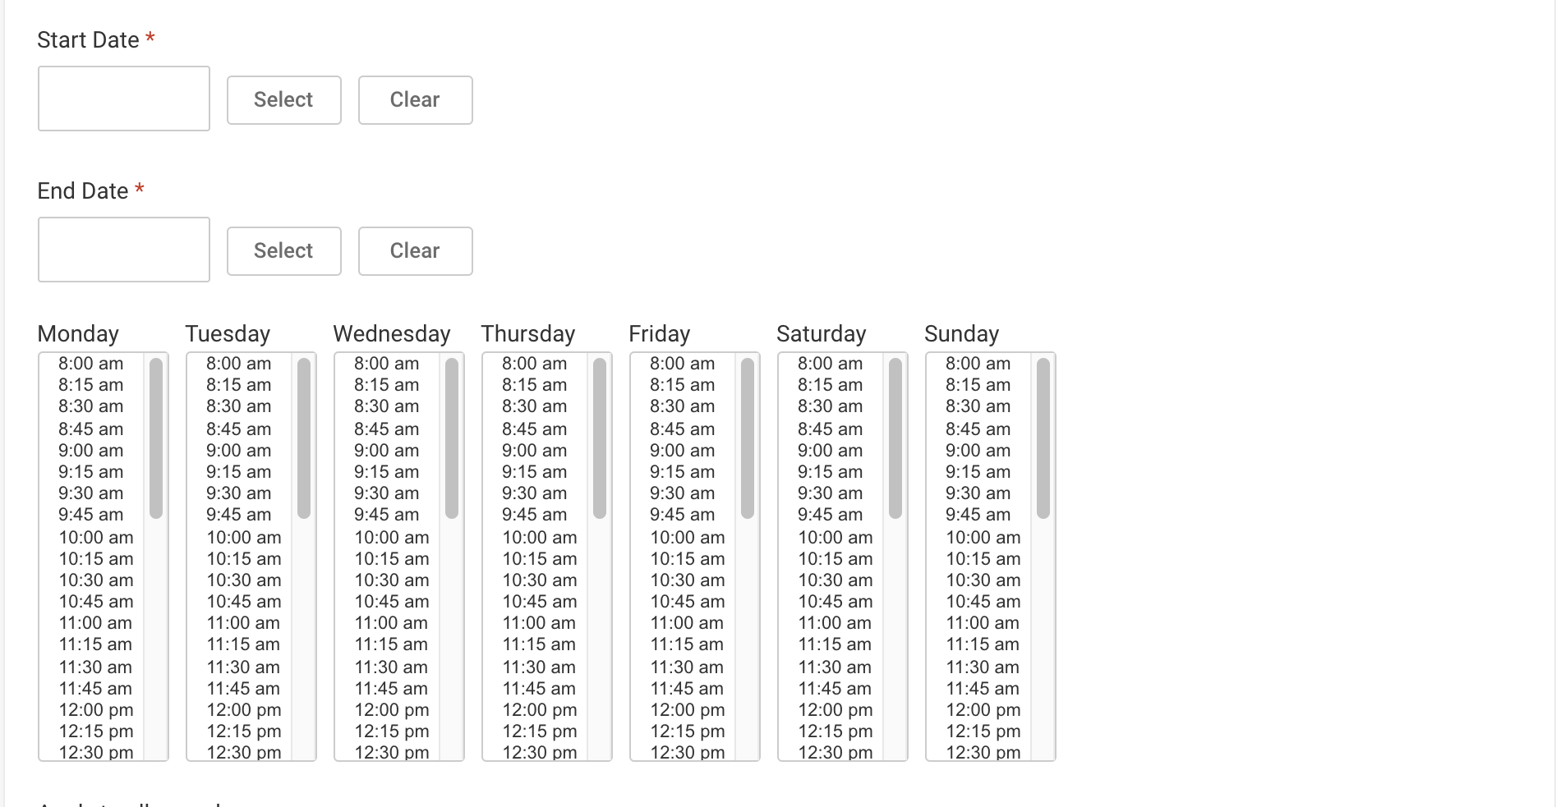

- Select “Apply to all records” to connect the exam to specific exam requests. This will not allow students direct access to your exam, but will allow the exam to be easily accessed by SAS to administer to your students.
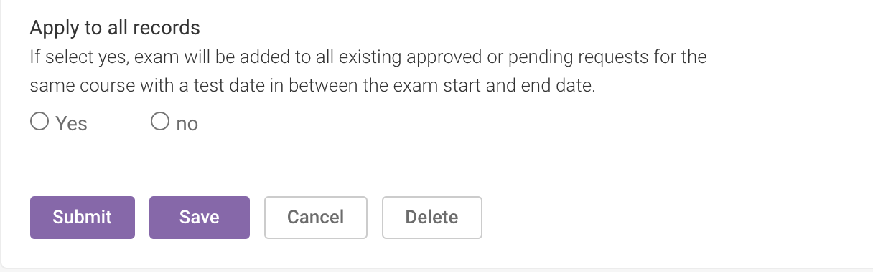

- Click "Submit."

If you have any questions, please contact SASoffice@naz.edu or 585-389-2875.

