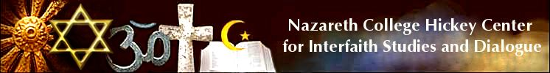
Global Citizenship Immersion Certificate Registration
Building skills and knowledge for a diverse world with visits to cultural and spiritual sites for experiential learning
Monday through Friday, August 5 – August 9, 2019, 1:30- 7:30PM
Please send this in soon or call the Hickey Center for registration
Name:

Affiliation: (school or other)

Your E-mail: Phone:

Mailing address:

Food Allergies/Dietary Restrictions/Medications/Special Accommodations:

What made you register for this program?

Registration fee: $199. Donations are welcome. Make check payable to “Hickey Center, Nazareth College”
And mail to: Hickey Center, Nazareth College
4245 East Ave, Rochester, NY 14618

