  - 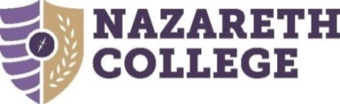

  - Staff Work Life Committee Meeting Notes
Wednesday, November 6, 2019
  - Attendance
Patricia Huntington, Rita Mannelli, Laura Putnam, Valarie Wilson, Stacey Stehle, Benny Thomas
Ex Officio: Cynthia Cusimano, (HR Representative), Patrick Richey, Cathy Stevens
Unable to attend: Ann Knaak

Discussion
- The minutes from October 3, 2019 SWLC meeting were approved as written and seconded.

- Events and Programs:
- Hot Chocolate & “Giving” S’mores – November 20th from 2 to 3pm at the Pavillion. The committee will accept donations of canned food items, winter coats, hats, gloves and scarves
- Holiday Wreath Contest to be displayed starting December 1st
- Mindfulness and Meditation Workshop to be offered by HR department

- Sick Leave Bank Proposal--for further discussion at the next meeting

- Web Page
Laura informed the committee that all minutes from previous meetings were posted and created an “Answer to Your Questions” section.

- Suggestions from Staff Members:
- Place for people to post non-work related items (recipes, request for recommendations, selling for tickets, looking for a ride, etc.).
- This is something that the SWL Committee is not going to handle and monitor, but individuals may have something coming up.
- Have someone come in and do a Medicare Workshop.
- Cynthia Cusimano will work on this project, more information to follow.

- Previous Survey Results
The committee looked at the survey results from last year and will respond to some of the items as time allows.

Respectfully submitted,

Erminda Hugh

