CAMP GUIDELINES AND PROCEDURES

Dear Parents:

We want to make your child’s week at Casa Italiana as stimulating, comfortable, safe and happy as possible. Please note the following guidelines:

Arrival

* Please accompany your child to the lower entrance of the Casa by 9:30 a.m. Please be punctual; you will not want to miss any of our activities! If you are early, kindly wait outside until the door is opened at 9:25 a.m.

* Due to space limitations within Casa Italiana, we ask that parents say their goodbyes outside on the patio.

* Please inform us in the morning when you drop off your child if someone other than yourself will be the pick-up person. This request must be made in writing.

End of the Day

* In order to ensure a smooth transition to the outdoors and for the security of your child, we ask that parents please wait outside on the patio until the children are dismissed individually, and to sign them out after your child is with you. Parents/Guardians are kindly asked to pick up children promptly!

Miscellaneous

* On the first day of camp, we will post a sign-up sheet at the lower entrance for parent observations. Observation times will be for Tuesday, Wednesday, and Thursday. This offers parents and other family members an opportunity to view the child at work and play.

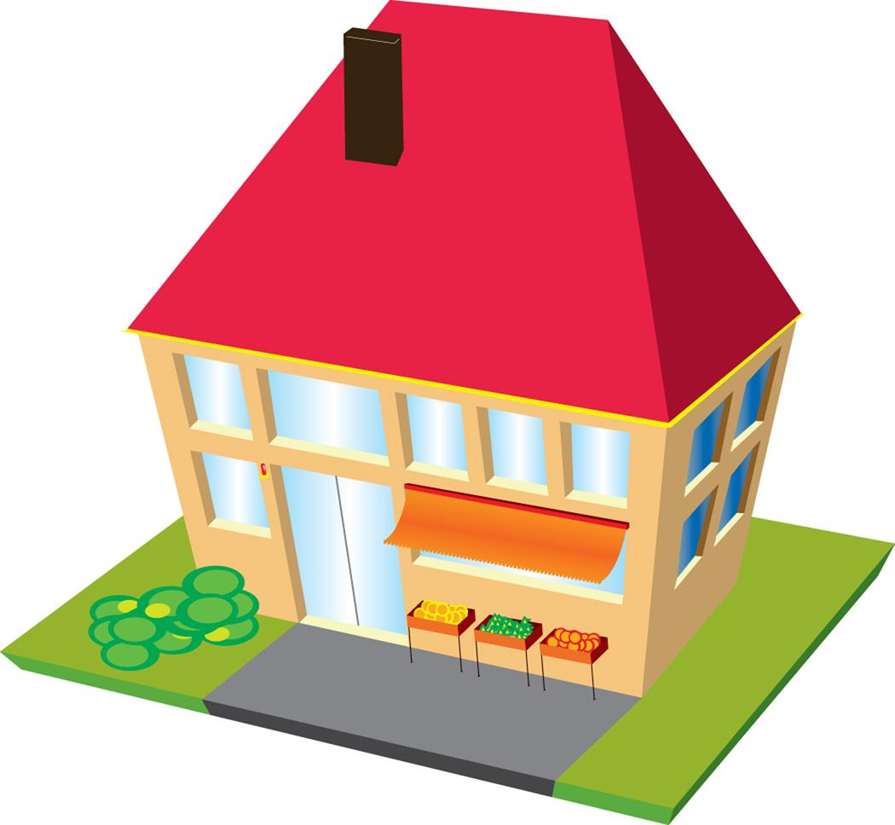
Family Celebration

On the last day of camp, we would like to invite you and your family members to attend a special program culminating our week of learning and fun. The event will take place at 2:30 p.m. in the Arts Center, room A14. On Friday, we would appreciate that your child be dressed in white top and dark skirt/shorts for our “Grand Finale.”

Open House

Come join us for our camp “Open House.” This will take place on Monday, the first day of camp. This will allow parents to discuss with the teachers what will happen during the week the child is at camp. Open House begins at 3:30 p.m.

Please feel free to speak with me at any time about your child’s experience at camp. We look forward to seeing you soon!

Sincerely,

Alana N. C. Bell

Casa Italiana Children’s Camp Program Leader

