Accommodate
Faculty Guide: How to View Student Accommodations
- Log into Accommodate.
- Select "Courses" on the left-hand sidebar.
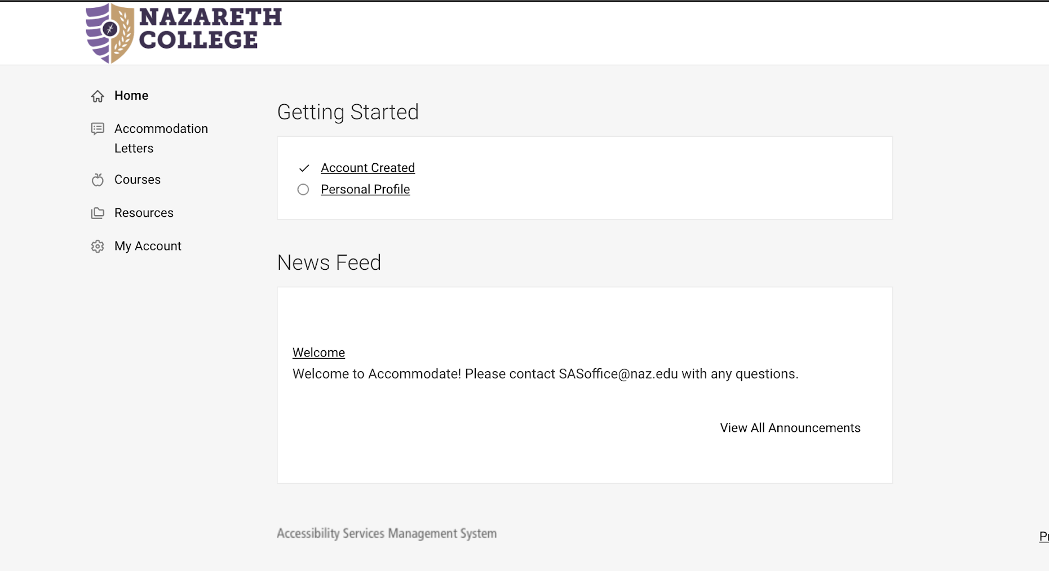

- Click on the course you’d like to view.
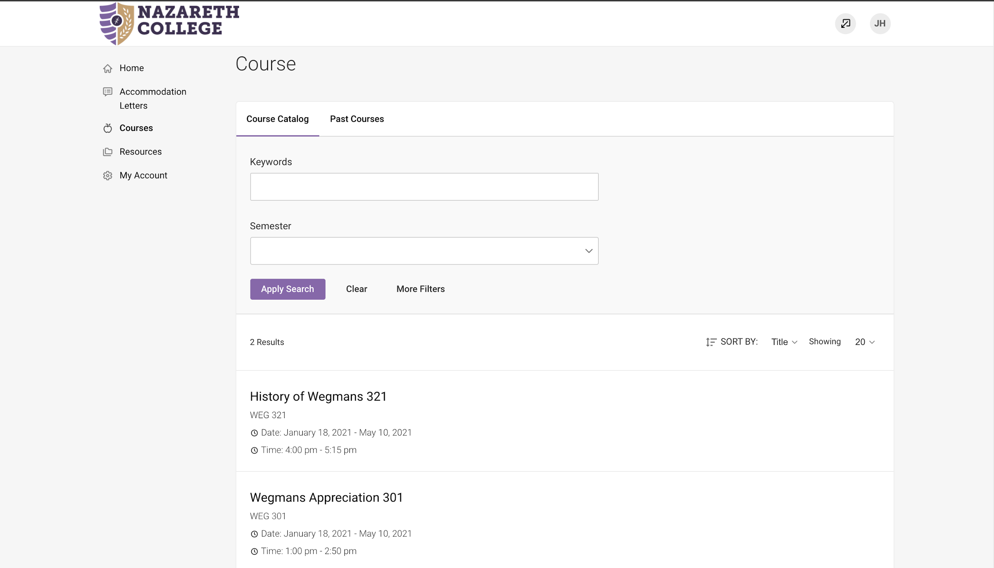

- Select "Enrolled Students."
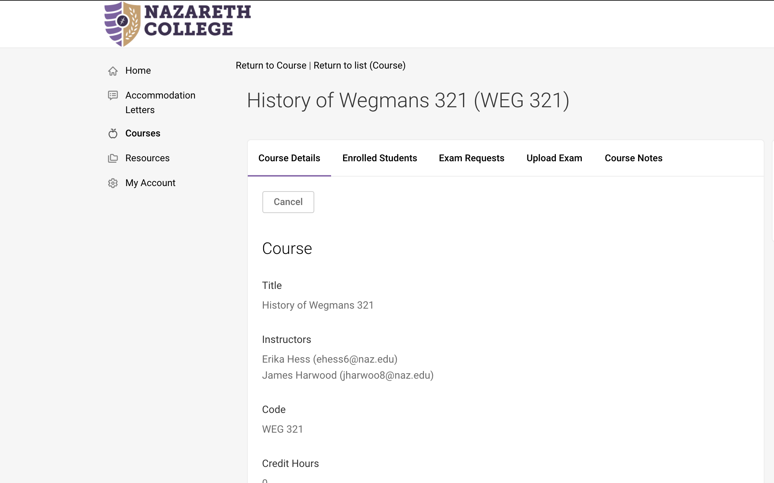

- You can either view the entire class, or filter by students who have approved accommodations. Click “More Filters.”
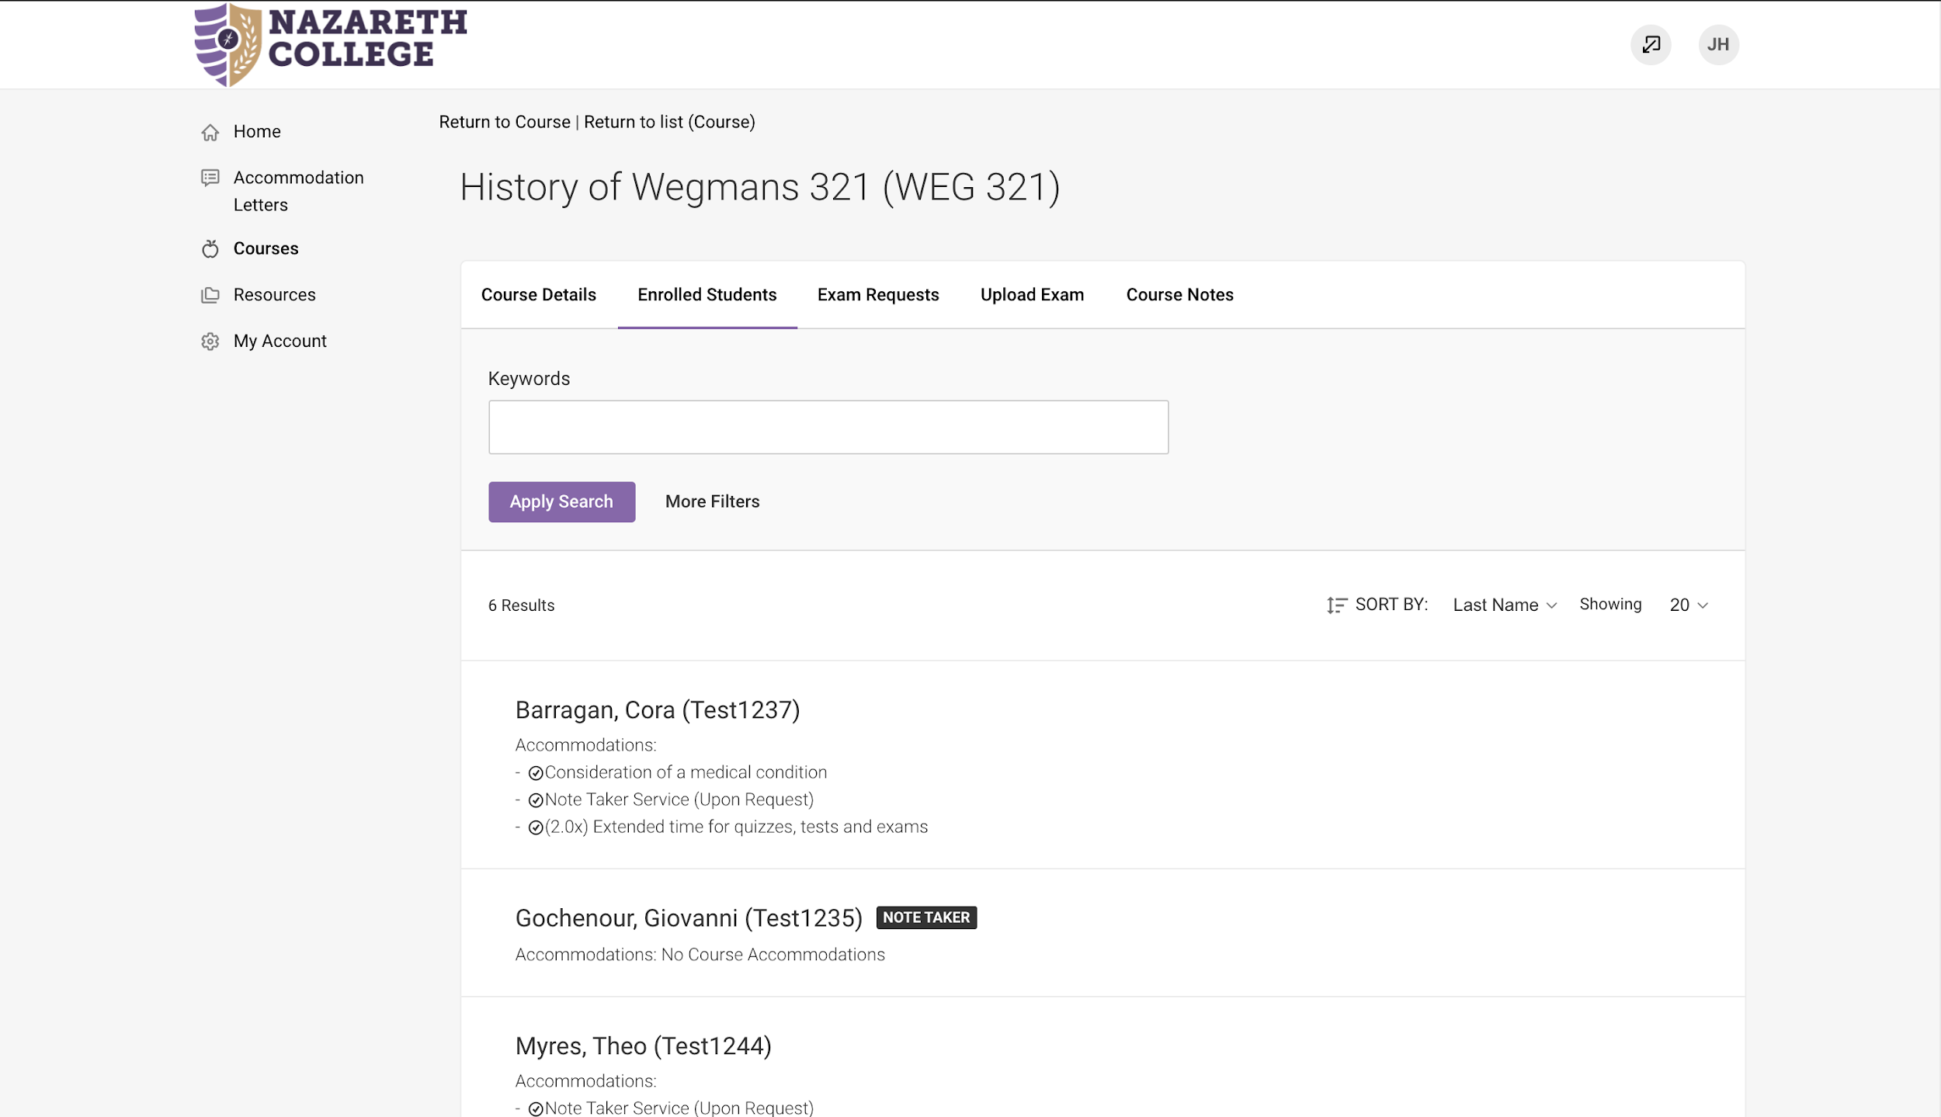

- Designate the semester and select Yes for “Approved Accommodations for this Course.”
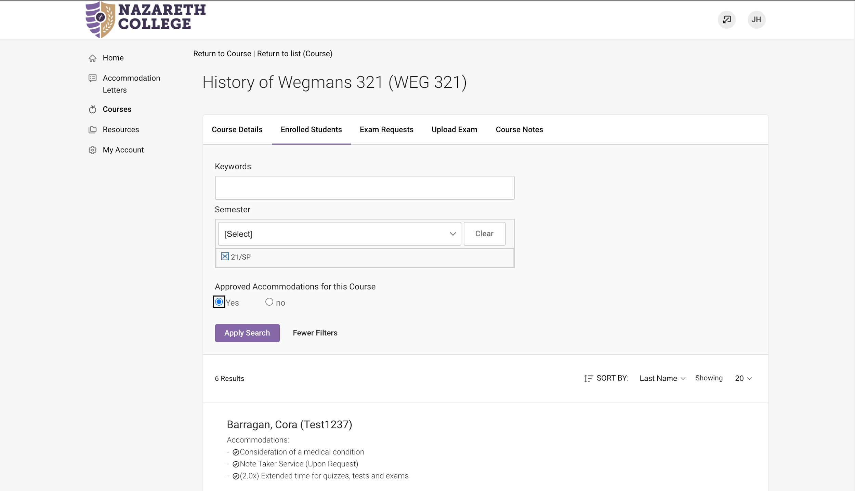

- View approved accommodations for students in your course.
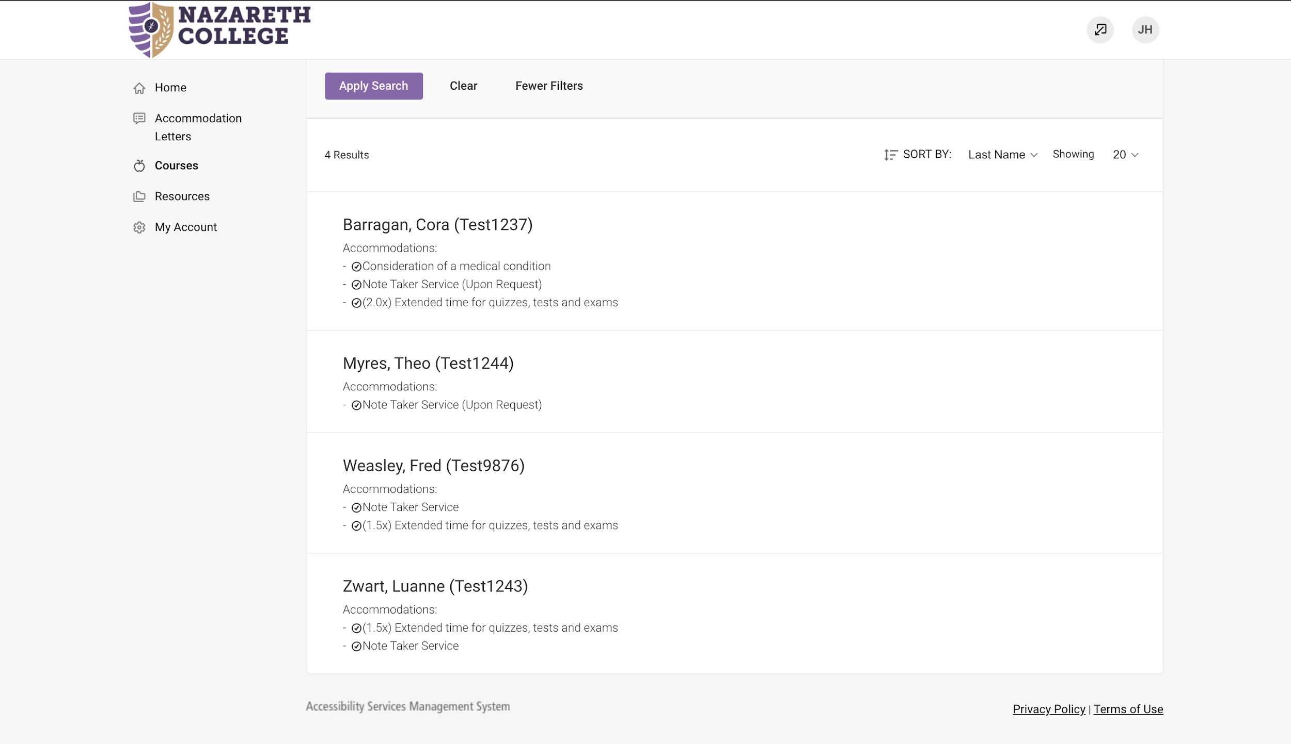

If you have any questions, please contact SASoffice@naz.edu or 585-389-2875.

