Accommodate
Faculty Guide: How to Approve Exam Requests
- Log into Accommodate.
- Select "Courses" on the left-hand sidebar.
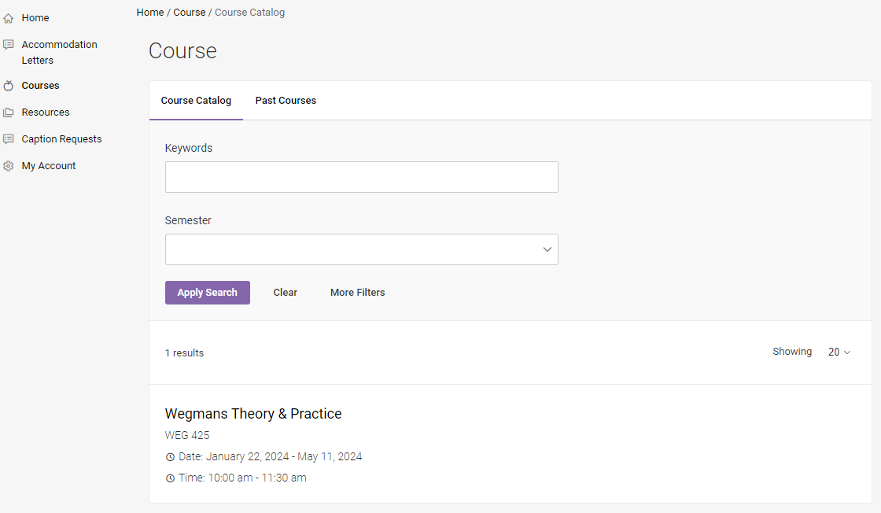

- Click on the course you received the request for. This will be listed in the email you receive when a student submits a request.

- Select "Faculty Confirmation of Request".
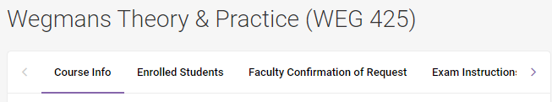

- Select “PENDING FACULTY CONFIRMATION” to view active requests. Please note, if the exam has already been approved by the testing center and you’ve received an approval confirmation, this exam request will show under “SAS APPROVED REQUESTS.”
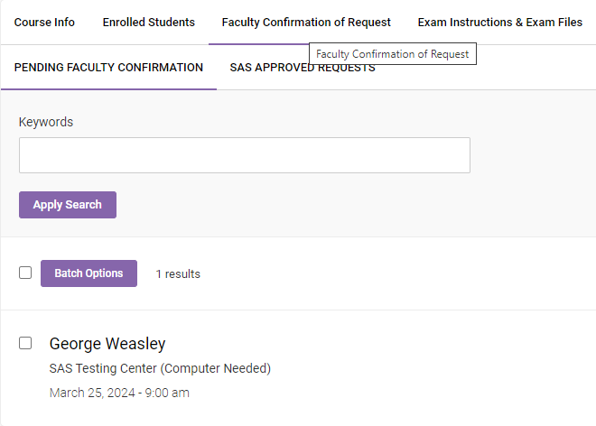

- Select the name of the student you would like to approve to take your exam.

- Review the Appointment Information. The “Appointment Length” will reflect the length of your exam with the student’s extended time applied. If this is inaccurate, please write a note under “Exam Instructions”.
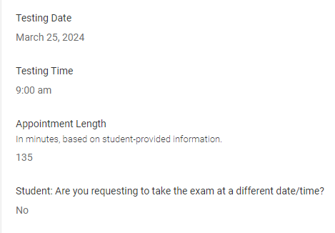

- Select ‘Yes’ for Faculty Member Approved Testing Request.
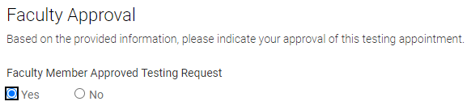

- Enter your exam information. Please be as specific as possible to ensure accurate delivery of your exam. Please upload your exam at this time.
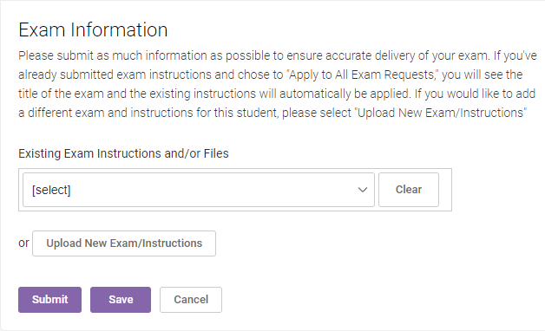

- If you noted the appointment length was inaccurate based on the student provided information, please specify the correct exam length for SAS to make an adjustment. This will be how long the class receives to take the exam, before extended time is applied.
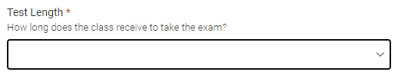
- Check off all materials that will be allowed during the exam and specify a preferred method of contact. Please note the date/time of the appointment and designate a way we will be able to contact you during that period. This will allow students to ask questions or address concerns.
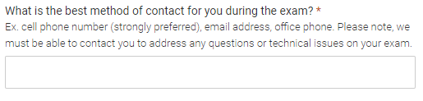
- Select how you would like the exam returned to you, as well as any extra notes you would like us to know.
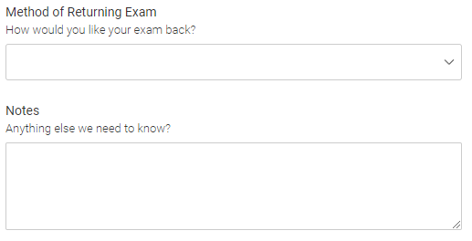
- If the exam instructions apply to all existing approved or pending exam requests for this course with a test date in between the exam start and end date, click ‘Yes’.
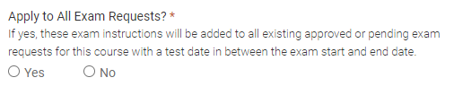

- Click “Submit.”

If you have any questions, please contact SASoffice@naz.edu or 585-389-2875.

