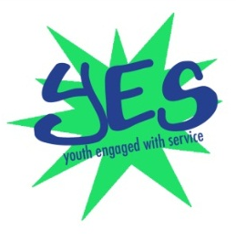

Y.E.S. Committee How can you say no to Y.E.S.?
A Service-Learning Partnership

What is YES?
Y.E.S. stands for Youth Engaged with Service. Y.E.S. is a youth-led partnership between
- The Rochester-Monroe County Youth Bureau’s Youth As Resources Program (YAR)
- The City of Rochester Bureau of Recreation’s Youth Voice, One Vision youth council (YVOV) and
- Nazareth College, Center for Service-Learning and Community Youth Development Minor (CYD)

Mission: YAR, YVOV, and CYD, as partners, will promote and practice the tenets of quality, youth driven service-learning throughout Monroe County.
History of YES
The Y.E.S. partnership was initiated through a civic engagement grant funded by the Rochester Area Community Foundation in 2004. With the seed dollars from the Community Foundation, the partnership with Nazareth’s Center for Service Learning and the Community Youth Development Minor, YVOV, and YAR focused upon civic engagement of city and county youth with the college community through service-learning activities. The Rochester Area Community Foundation continues to fund some of the project, with major components of the project institutionalized within the respective institutions: Nazareth College, City of Rochester Bureau of Recreation, and the Rochester-Monroe County Youth Bureau. Each institution offers specific areas of expertise: Nazareth College offers the expertise in the theory, design, implementation and evaluation of youth development focused service-learning. YVOV and YAR bring expertise in the application of positive youth development with the best practices of engaging with youth. Y.E.S. members, in collaboration with Nazareth College students, lead and participate in:
- bi-weekly meetings
- service-learning projects (Ex. Cardboard City, Global Youth Service Day, Be the Change Day, Steppin’ Up to Solutions youth conference, CYD Classes)
- youth-led workshops related to service-learning and other topics
- service-learning and youth leadership conferences

Why Service-Learning?
School is not the only setting where youth can learn and grow. Young people and communities alike benefit from community-based service-learning. Service-learning is different from volunteering. It is “a teaching and learning strategy that integrates meaningful community service with instruction and reflection to enrich the learning experience, teach civic responsibility, and strengthen communities” (Learn and Serve America, National Service Learning Clearinghouse). Eugene C. Roehlkepartain of the Search Institute lists the following benefits of service learning:

Benefits for Youth Participants
- Young people gain access to the range of supports and opportunities (or developmental assets) they need to grow up healthy, caring, and responsible. One study of youth civic activism found that these settings had particular strength in cultivating youth and community involvement.
- Increased sense of self-efficacy as young people learn that they can impact real social challenges, problems, and needs.
- Higher academic achievement and interest in furthering their education.
- Enhanced problem-solving skills, ability to work in teams, and planning abilities.
- Enhanced civic engagement attitudes, skills and behaviors. Many leaders in public service today speak about how they were nurtured, inspired, and shaped in early experiences in community service or volunteering.

Benefits for Youth Development Organizations
- Young people are more likely to stay engaged when they feel their participation is meaningful and they can make useful contributions through service and social action.
- Service-learning gives an intentional strategy for addressing goals for learning and personal development through civic engagement and community service.
- Service-learning can cultivate connections between the organization, schools, and other community groups.
- Service-learning can increase program staff and volunteers' level of engagement, leadership capacity, and satisfaction with their work.

Benefits to Organizations that Utilize Young People as Volunteers
- The opportunity to expand their mission and reach without substantially increasing costs by engaging a cadre of competent, motivated young people who share their time and talents in support of the organization's mission.
- New energy, ideas, and enthusiasm as well as specialized skills that young people can bring to the organization.
- Increased public support and visibility in the community as young people become ambassadors for the agency in their schools, homes, and other networks.
- New partnerships and resources that emerge when agencies form service-learning partnerships with schools, youth development organizations, faith-based organizations or others that provide service-learning as part of their programming.
- By working with youth and getting them committed to its mission, an organization cultivates a new generation of volunteers for either their own organization or their broader cause.

Benefits for Service Recipients, Communities, and Society
- It meets real needs and priorities for individuals and communities, as young people bring new energy, capacity, and creative ideas.
- Community residents have opportunities to build positive relationships with young people.
- Communities see youth in a different way—as resources, not problems.
- A new generation of caring and experienced citizens, activists, and volunteers is cultivated.

Steps to Service-Learning
There are wide range of approaches and methods to executing service-learning. Y.E.S. uses the “5 R’s of Service-Learning” created by Dr. Marie Watkins, Professor, Nazareth College.

“The Five R’s of Service-Learning”
- Rigorous active learning: Young people, community members and college partners identify shared learning and growth opportunities.
- Responsible and relevant service: The service-learning project addresses mutual interests about community issues through meaningful and impactful service.
- Reciprocity and relationships: Young people, community and campus partners engage and learn together as they build upon each other’s strengths and resources during the service-learning project’s planning, implementation and evaluation processes.
- Reflection, ongoing: Organized, ongoing and structured “reflective pauses” are intentionally planned to guide the development of a deep understanding of the purpose, meaning, and benefits of the service-learning project.
- Recognition and celebration: It is important to recognize all individuals who have contributed to the project and to end with a celebration for a job well done.

City of Rochester Bureau of Recreation  400 Dewey Avenue • Rochester, NY 14613  Ph: (585) 428-7371 • F: (585) 428-6021  www.cityofrochester.gov/yvov |  | Nazareth College Center for Service Learning  4245 East Avenue • Rochester, NY 14618  Ph: (585) 389-2748  www.naz.edu/dept/servicelearning |  |  | Rochester-Monroe County Youth Bureau  435 East Henrietta Rd F3-W • Rochester, New York 14620  Ph: (585) 753-6456 • F: (585) 753-6465  www.monroecounty.gov/youth-resources.php
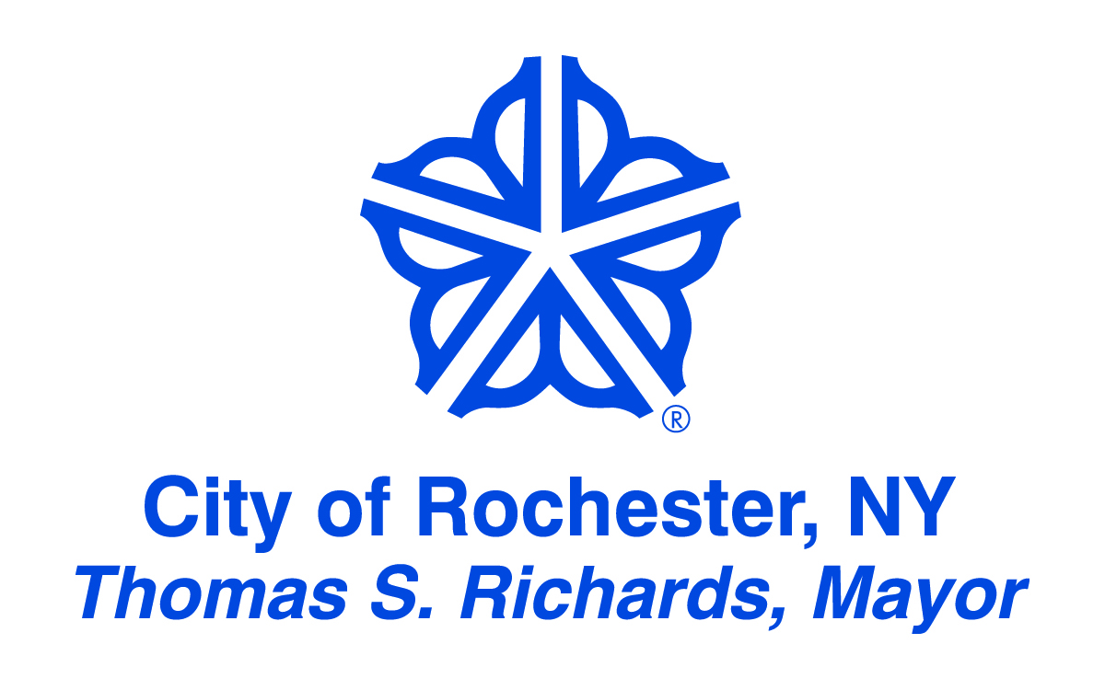 |  |  | 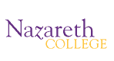 |  |  | 