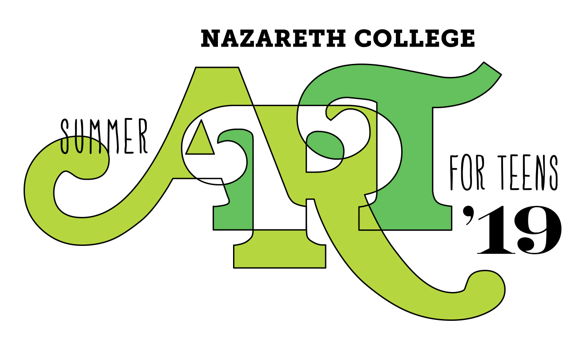

WHAT: Are you a student age 13-18 with artistic talents and interests in the visual arts? Learn from professional artists and build your portfolio! Demonstrate your skills in a final art exhibit.

WHO: Nazareth Art Faculty –
Professor Mitch Messina: Ceramics & Sculpture
Professor Ron Netsky: Drawing & Painting

WHERE: Classes will be held on Nazareth College’s nationally known Arts Center Campus.

WHEN: July 8 – 26, 2019.
Monday–Friday 9 AM–2:30 PM

REGISTRATION

COST: $675 Registration Fee; includes all materials.
No refunds can be issued after 90 days and after June 1 – whichever comes first, except in extra ordinary circumstances approved by the Director of Summer Art For Teens, Ron Netsky.

HOW: ONLINE – https://www2.naz.edu/dept/art/summer-art/

BY PHONE, using a credit card, please call the Art Dept. at
389-2532.

BY MAIL, send registration forms and payment to:

Nazareth College Art Department
Nazareth Summer Art For Teens
4245 East Ave.
Rochester, NY 14618

Registrations will be accepted through June 15th OR until classes are filled.
Classes are filled according to the order in which registrations are received. Limited enrollment offers students individualized attention.

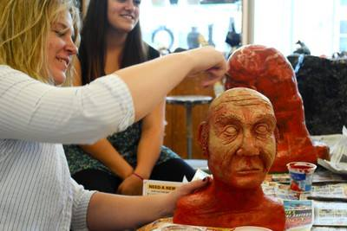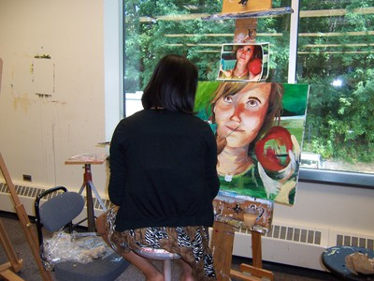

STUDENT REGISTRATION — NAZARETH SUMMER ART FOR TEENS 2019
July 8-26 2019, Monday – Friday 9 am-2:30 pm

STUDENT NAME ____________________________ PREFERRED FIRST NAME: ___________

MALE FEMALE OTHER: ______________________

STREET ADDRESS ___________________________________________________

TOWN/CITY _______________________________ ZIP CODE ________________

E-MAIL ADDRESS ____________________________________________________

SCHOOL DISTRICT ___________________________________________________

SCHOOL ____________________________________________________________

PARENT/GUARDIAN _________________________________________________

PARENT/GUARDIAN WORK PHONE ___________________________________

GRADE ENTERING IN FALL 2019 _________________ AGE IN JULY _______

GUARDIAN #1 NAME & PHONE NUMBER: ______________________________

GUARDIAN #2 NAME & PHONE NUMBER (if none leave blank): _____________________________________________________________________

Payment Information:

Terms of Payment:
By submitting the registration now, I understand that no refunds can be issued after 90 days and after June 1 – whichever comes first, except in extra ordinary circumstances approved by the Director of Summer Art For Teens Professor Ron Netsky.

VISA/MC ______________________________ 3 digit code: _________ EXP DATE: _______

NAME ON CARD _______________________________________________________

If paying by check, please make check payable to Nazareth College Art Department.

Mail forms and payment information to: Nazareth College Art Dept.
Nazareth Summer Art For Teens
4245 East Ave
Rochester, NY 14618

HEALTH RECORDS FOR TEENS IN SUMMER ART FOR TEENS

_________________________ ________________________ ____/____/_____
^{STUDENT’S LAST NAME} ^{STUDENT’S FIRST NAME} ^{DATE OF BIRTH}
_________________________ ________________________
^{HOME ADRESS} ^{CITY/STATE/ZIP CODE}
___________________ ______________ ____________ ____________
^{GUARDIAN #1’S NAME} ^{CELL PHONE NUMBER} ^{WORK PHONE NUMBER} ^{HOUSE PHONE NUMBER}
___________________ ______________ ____________ ____________
GUARDIAN #2’S NAME – IF NONE, ALTERNATE EMERGENCY CONTACT ^{CELL PHONE NUMBER} ^{WORK PHONE NUMBER} ^{HOUSE PHONE NUMBER}

IF PARENT OR GUARDIAN IS NOT AVALIABLE IN CASE OF AN EMERGENCY, NOTIFY (FAMILY PHYSICIAN/PEDIATRICIAN)
__________________________________ _________________________
^{FAMILY PHYSICAN} ^{TELEPHONE}

HEALTH HISTORY (Check, giving approximate dates of last incident):
^{Asthma: ________________} ^{Behavior: ________________} ^{Chicken Pox: ______________} ^{Convulsions: ______________}
^{Diabetic: ________________} ^{Ear Infection: _____________} ^{Hay Fever: ________________} Abnormal Reaction to Insect Stings: ______________
^{Ivy Poisoning: ____________} ^{Measles: _________________} ^{German Measles: ___________} ^{Mumps: __________________}
Disabilities/conditions: __________________________________________________________________________________________________________
Allergies (medications, food, etc.): _________________________________________________________________________________________________
Operations or Serious Injuries (Dates): ______________________________________________________________________________________________
Hospitalization: ________________________________________________________________________________________________________________
Chronic or Recurring Illness: ______________________________________________________________________________________________________
Other medical information you wish to share (life changing events, phobias, etc.): ___________________________________________________________
Any specific activities to be encouraged? _____________________________________________________________________________________________________________________________________________________________________________________________________
Any specific activities to be restricted? ______________________________________________________________________________________________________________________________________________________________________________________________________
Suggestions from Parents(s) or Guardian: _________________________________________________________________________________________________________________________________________________________________________________________________
____________________________________________________________________________________________________________________________________________________________________________________________________________________________________

MEDICATIONS (Please list):
Medications to be carried during Summer Art For Teens: _________________________________________________________________________________________________________________________________________________________________________________
Medications taken during Summer Art For Teens: _______________________________________________________________________________________________________________________________________________________________________________________
Family Physician’s Permission to carry OTC and /or Prescription Medicine at Summer Art For Teens:
_________________________________________________ _________________________________________________ ______________________________ _____________________________
^{PRINT DOCTOR’S NAME} ^{DOCTOR’S SIGNATURE} ^{DATE} ^{TEL #}
*Nazareth College and its employees cannot be held responsible for medication administration.
I hereby give my consent/authority to the Staff of the Summer Art For Teens to obtain the necessary emergency medical treatment for my child with the understanding that the guardians will be notified as soon as possible.
Relationship: ___________________________________ Signature: _______________________________________
Telephone: _____________________________________ Date: ___________________________________________

-- STUDENT RELEASE FORM --

Student Pick-Up Authorization for (Student’s Name)

☐LIMITED AUTHORIZATION:
The following individuals are the only ones authorized to pick up the student from Nazareth College Summer Art For Teens and will be required to provide a picture ID when signing the student out. I understand that: 1) It is my responsibility to arrange for the student to be picked up at the Arts Center Loop between 2:30 and 2:45, and; 2) After 2:45, I am solely responsible for the student’s safety.

1) Name:

Relationship:
Phone #

2) Name:

Relationship:
Phone #

3) Name:

Relationship:
Phone #

☐UNLIMITED AUTHORIZATION:

The student is allowed to self-drive and/or leave with anyone. In this case, I understand that Nazareth College and its employees cannot be held responsible for the safety of the student.

Parent/Guardian's Signature Date

